February 22, 2023-Virtual

Effective Communication with Your Family

*Comunicación Efectiva con Tu Familia*

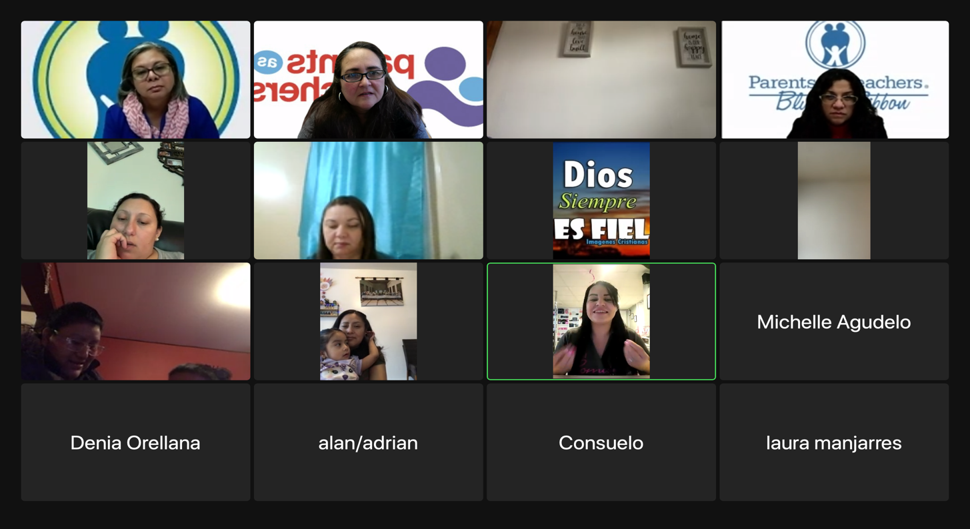

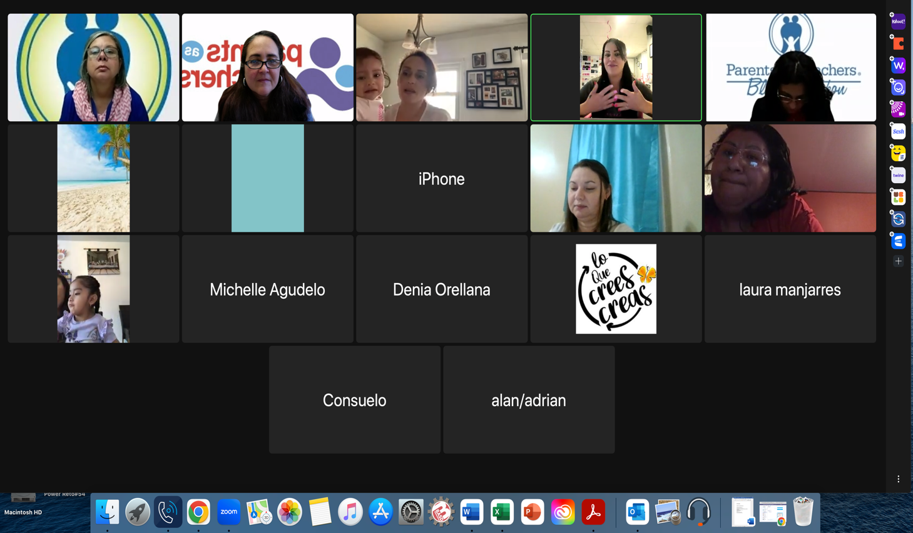

February 22, 2023-Virtual

Effective communication with Your Family

*Comunicación Efectiva con Tu Familia*

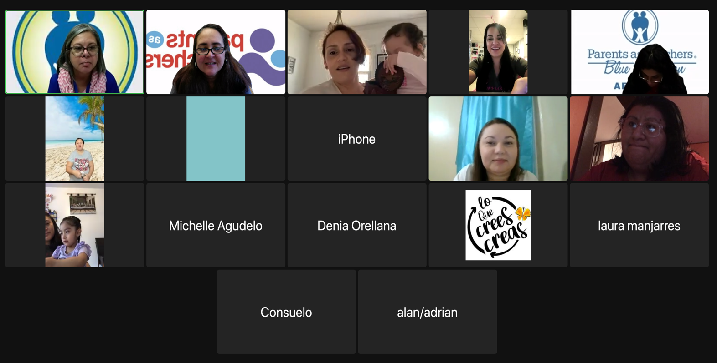

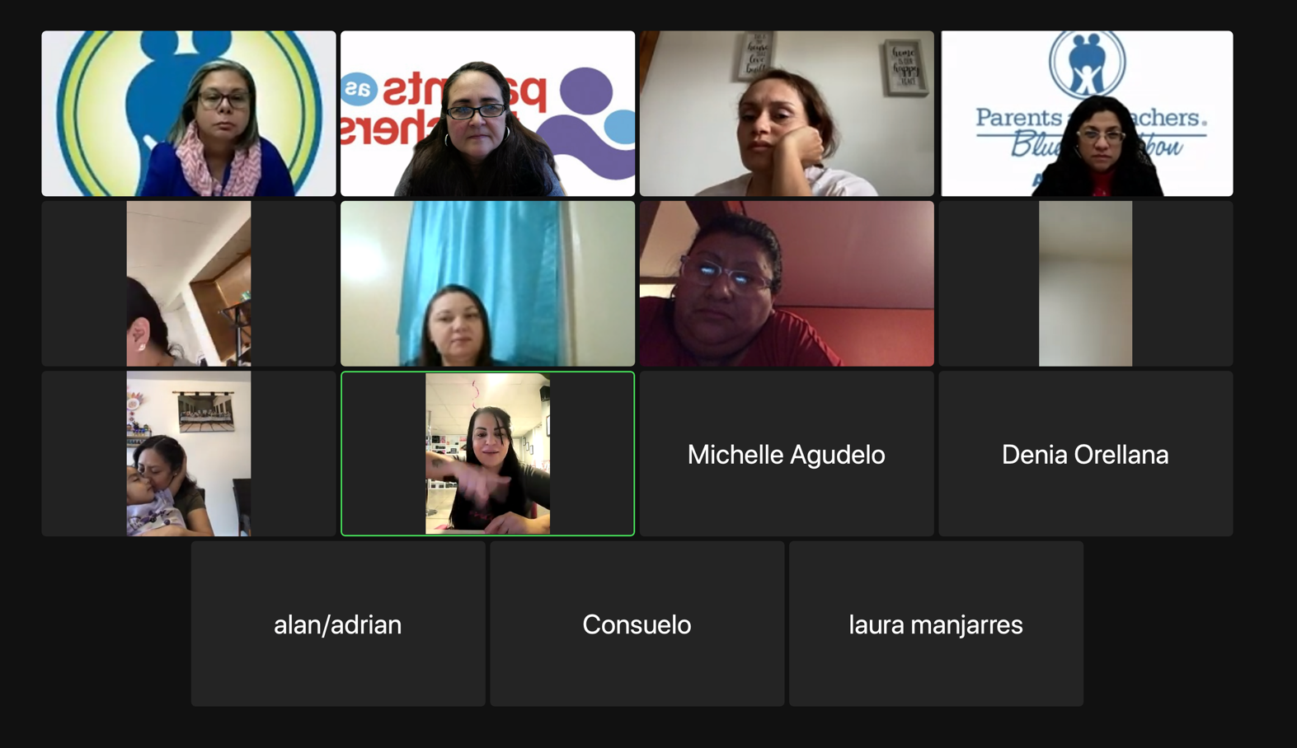

February 22, 2023-Virtual

Effective communication with Your Family

*Comunicación Efectiva con Tu Familia*

